**ESXI COMMANDS (open esxi in putty)**

**Username: root**

**Password:Admin@123**

1. **cd /usr/sbin(List all standard vm specific tools)**
2. **ls**

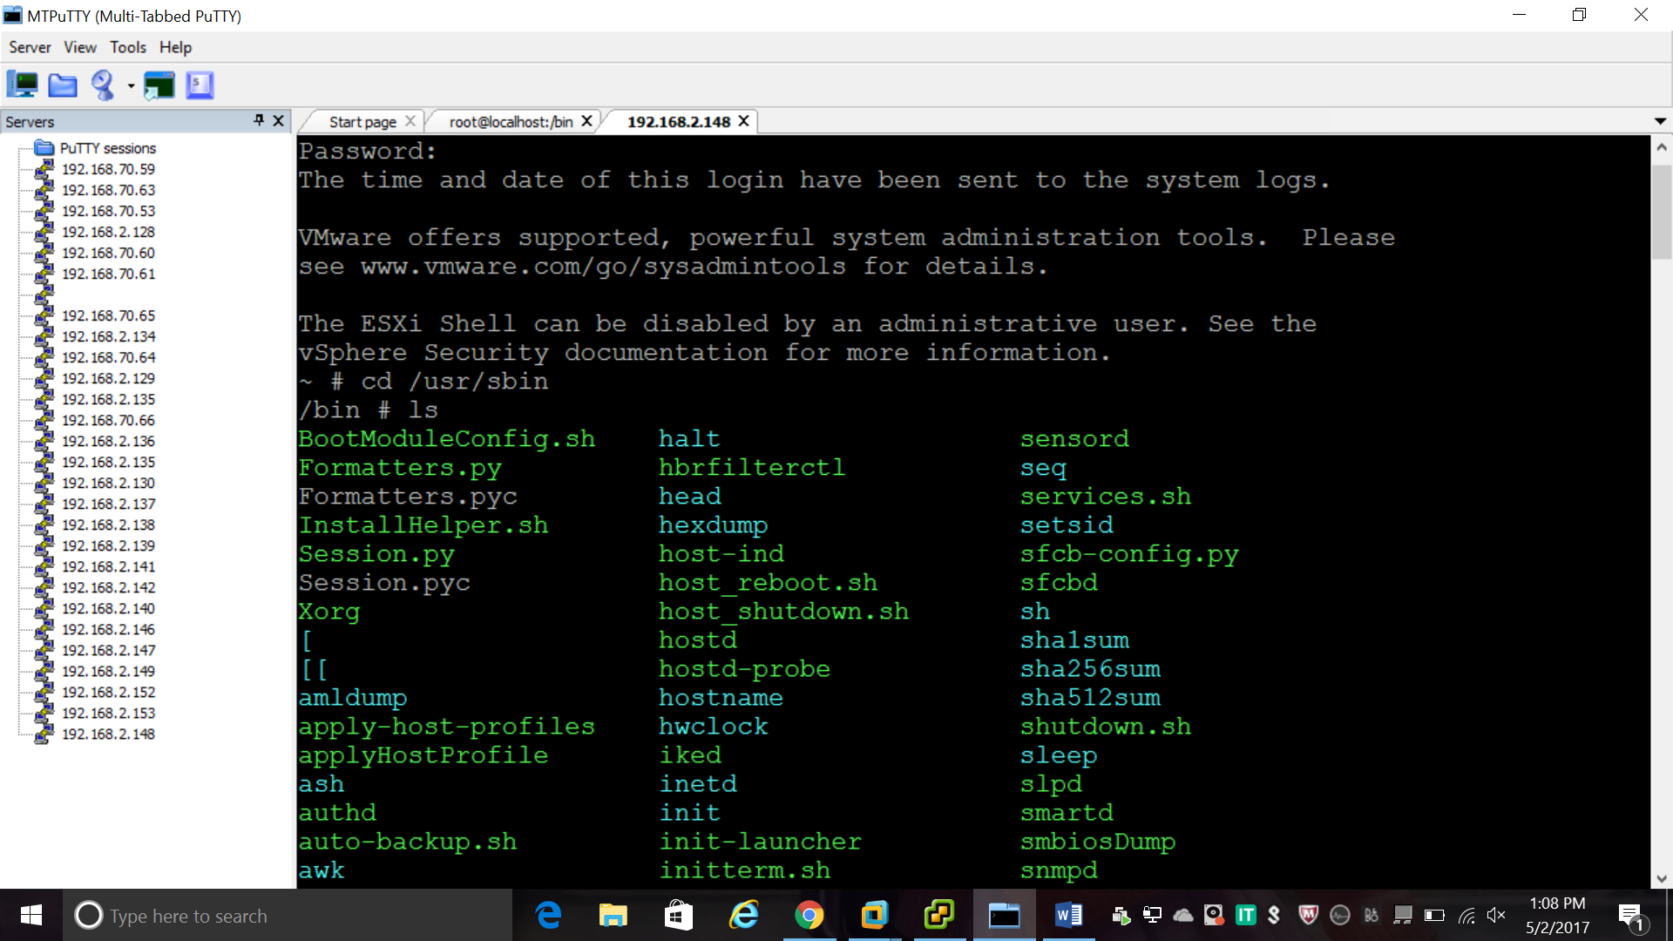

1. **esxcfg-nics**

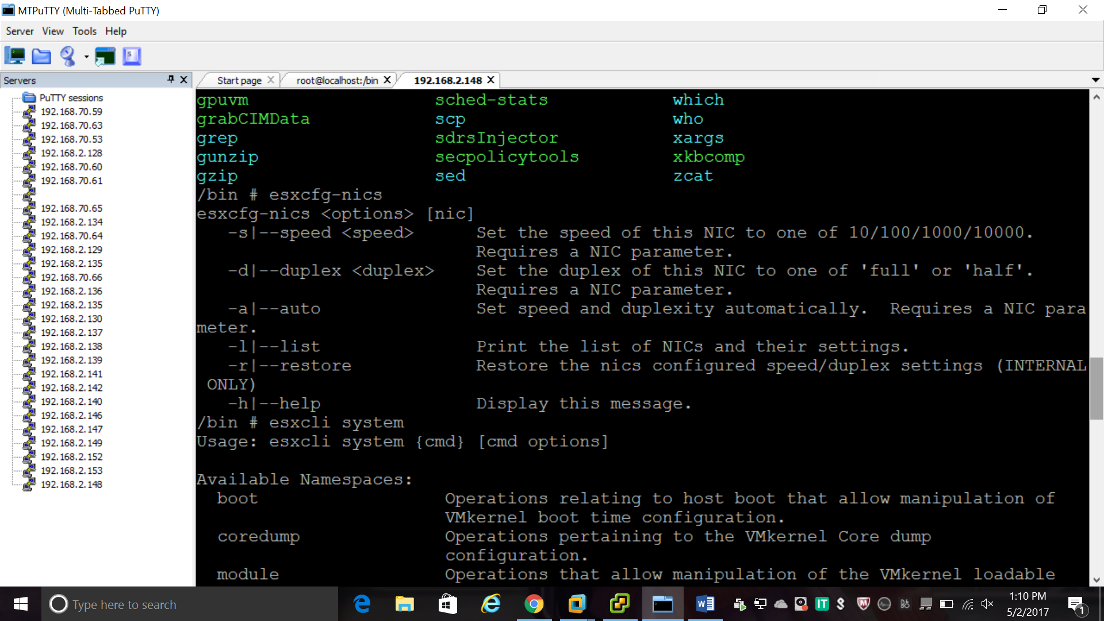

1. **esxcli system**

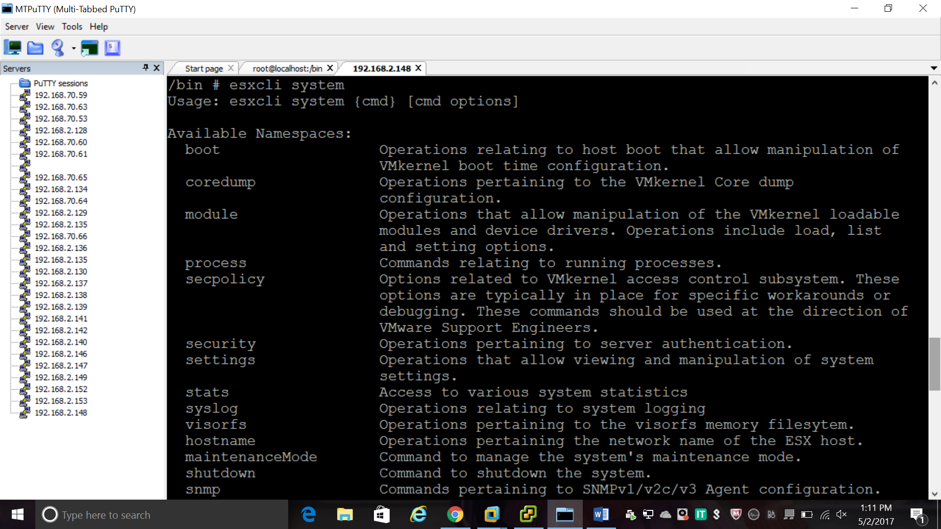

1. **esxcli system shutdown**

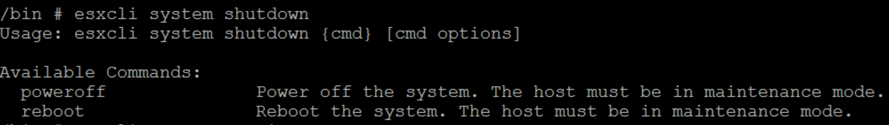

1. **esxcli system version get**

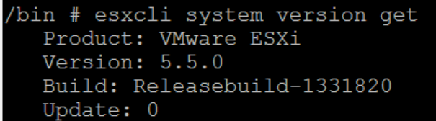

1. **esxcli storage**

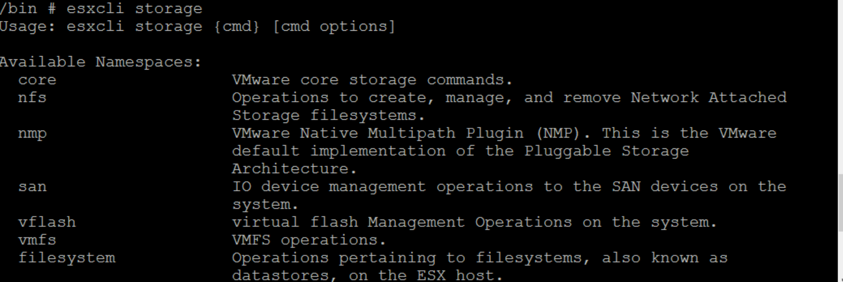

**ESXI NETWORK COMMANDS:**

1. **esxcli network**

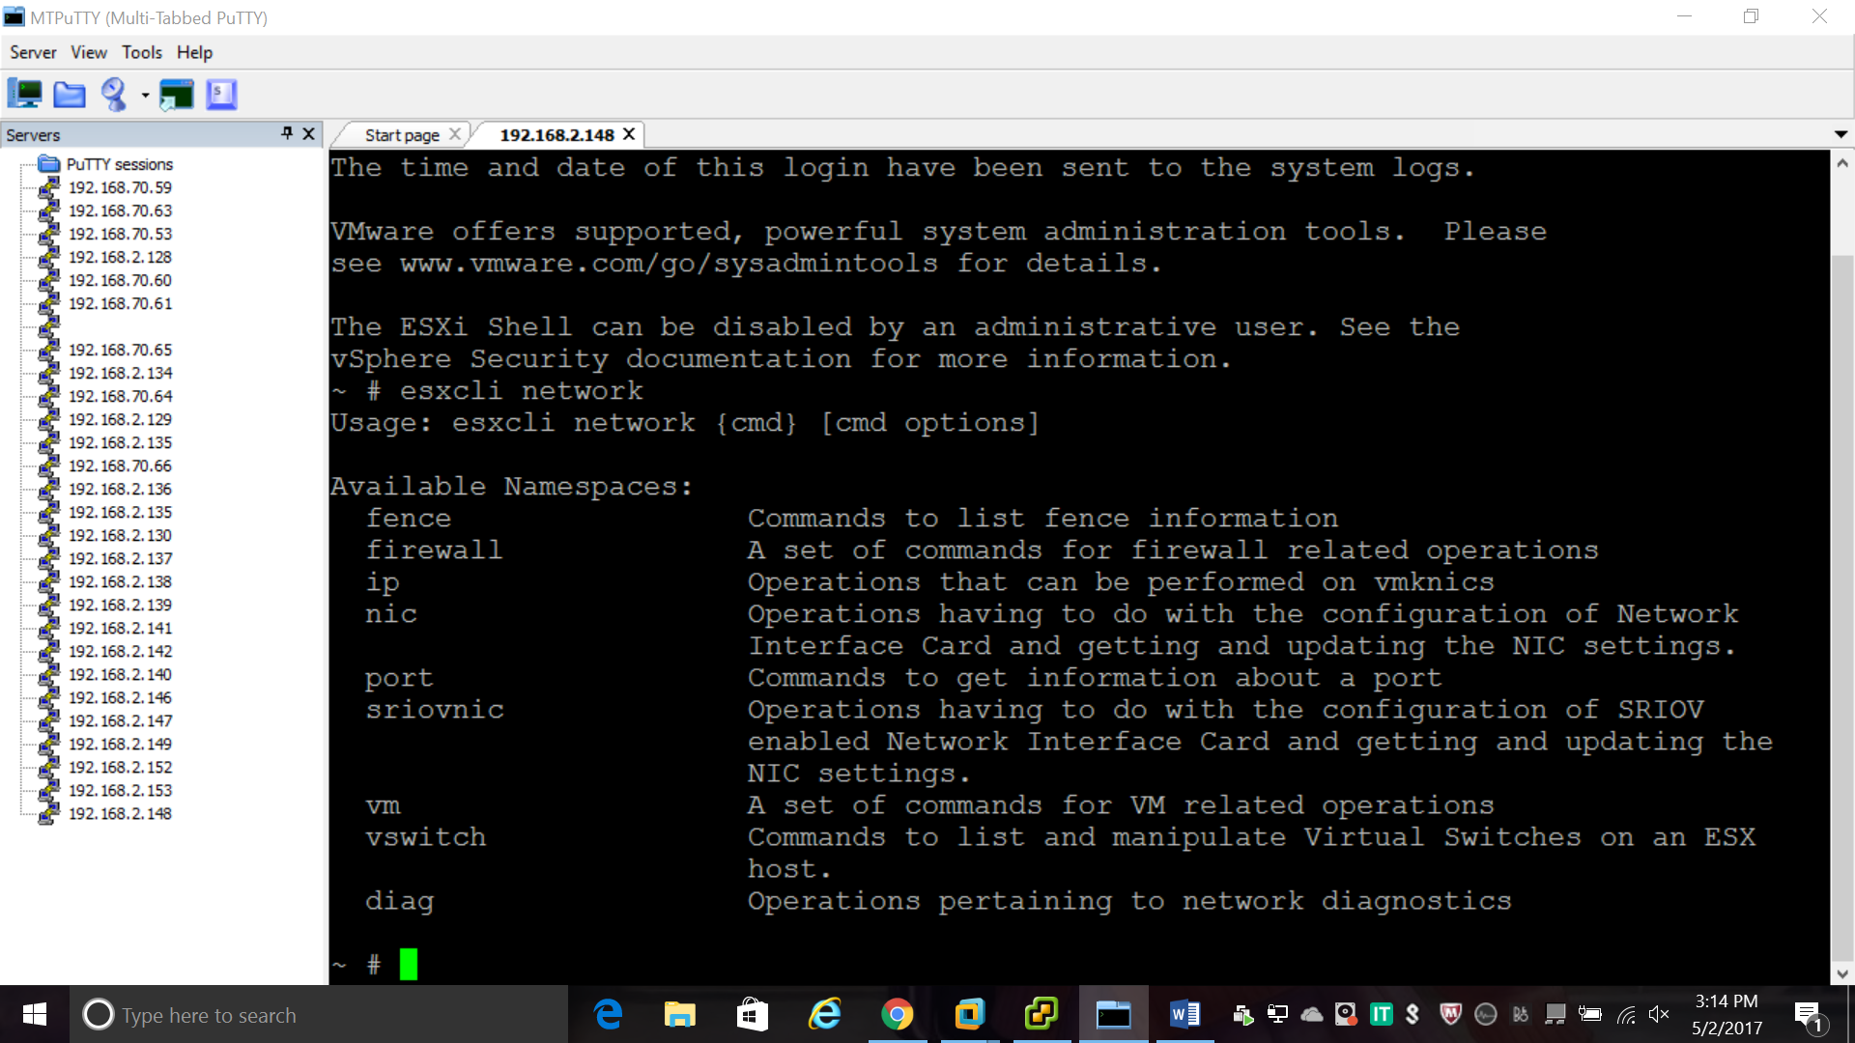

1. **esxcli network nic**

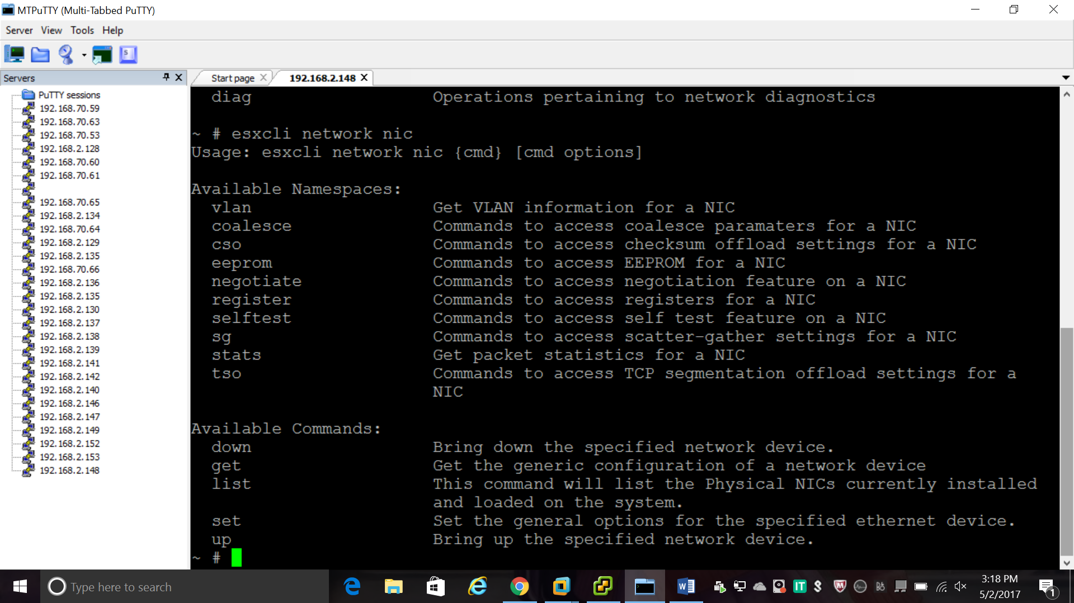

1. **esxcli network nic list**

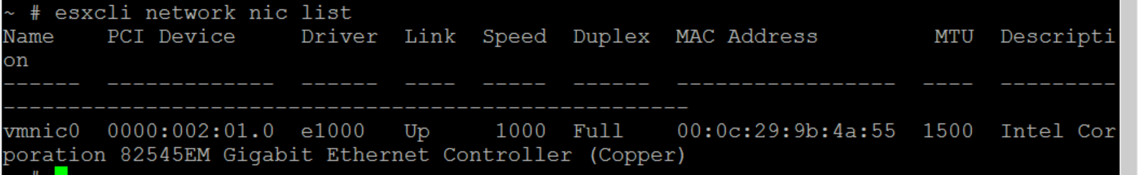

1. **vim-cmd vmsvc/getallvms**

List all Vm’s Running on Hypervisor and Provides VMid

1. Power ON/OFF vimid referenced from getallvms command

Power ON --- ***vim-cmd vmsvc/power.on vmid***

***vim-cmd vmsvc/power.on 1***

Power Off --- ***vim-cmd vmsvc/power.off vmid***

***vim-cmd vmsvc/power.off 1***

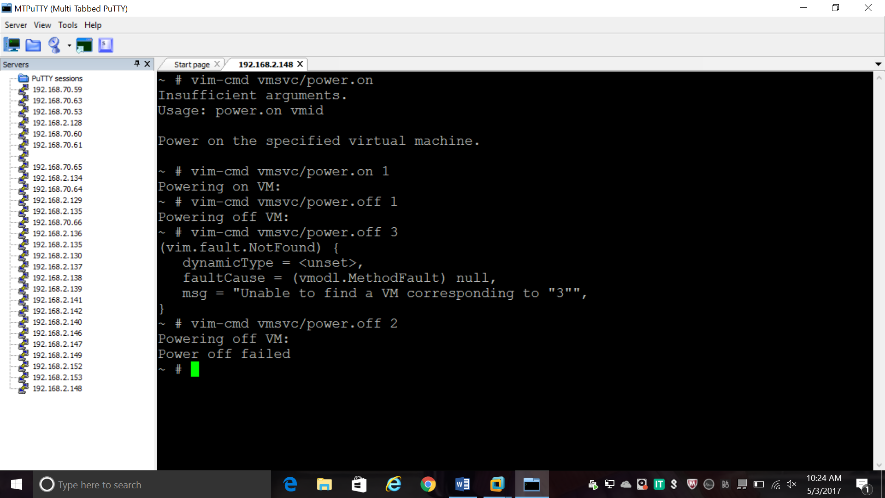

1. **Vim-cmd vmsvc/power.reboot vimid**

Power Reboot--- ***vim-cmd vmsvc/power.reboot vmid***

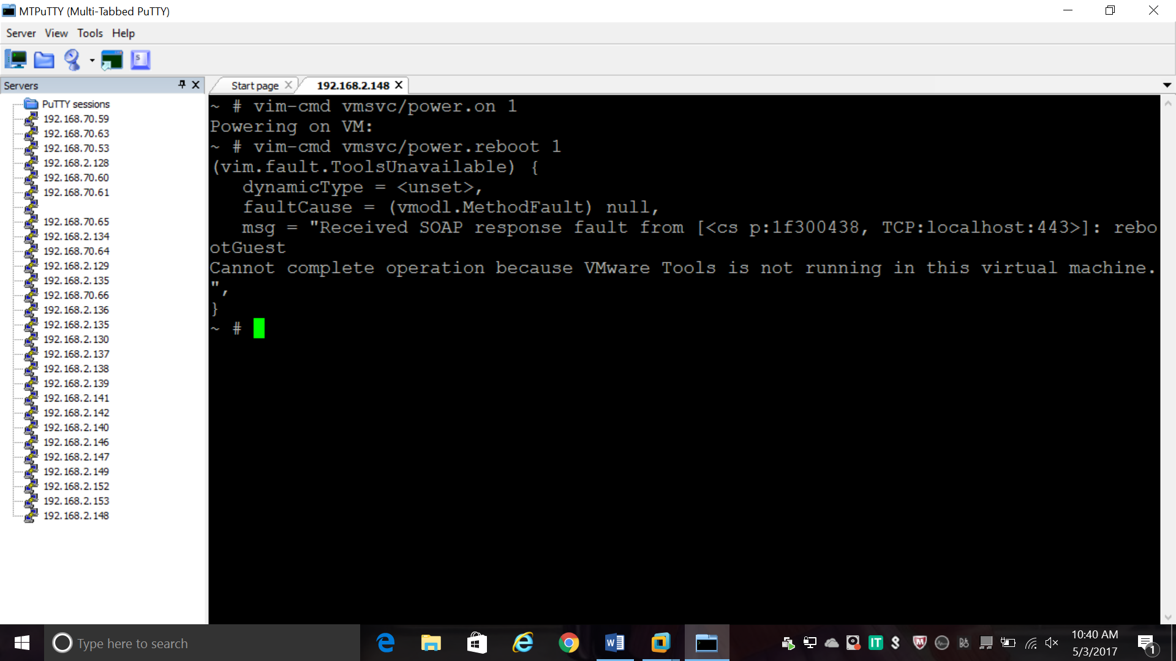

1. Deletes the vmdk and vmx files from disk

**Vim-cmd vmsvc/power.destroy vimid**

Power destroy--- ***vim-cmd vmsvc/power.destroy 1***

1. Puts/Takes hypervisor into maintenance mode

***vim-cmd hostsvc/maintenance_mode_enter***

***vim-cmd hostsvc/maintenance_mode_exit***

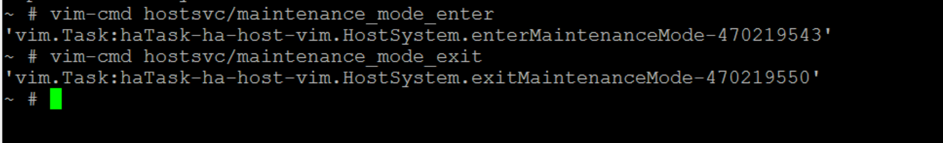

1. Tools Installation(Starts vmware tools installation for vm)

***vim-cmd vmsvc/tools.install vmid***

1. Provides information about hypervisor networking

***vim-cmd hostsvc/net/info***

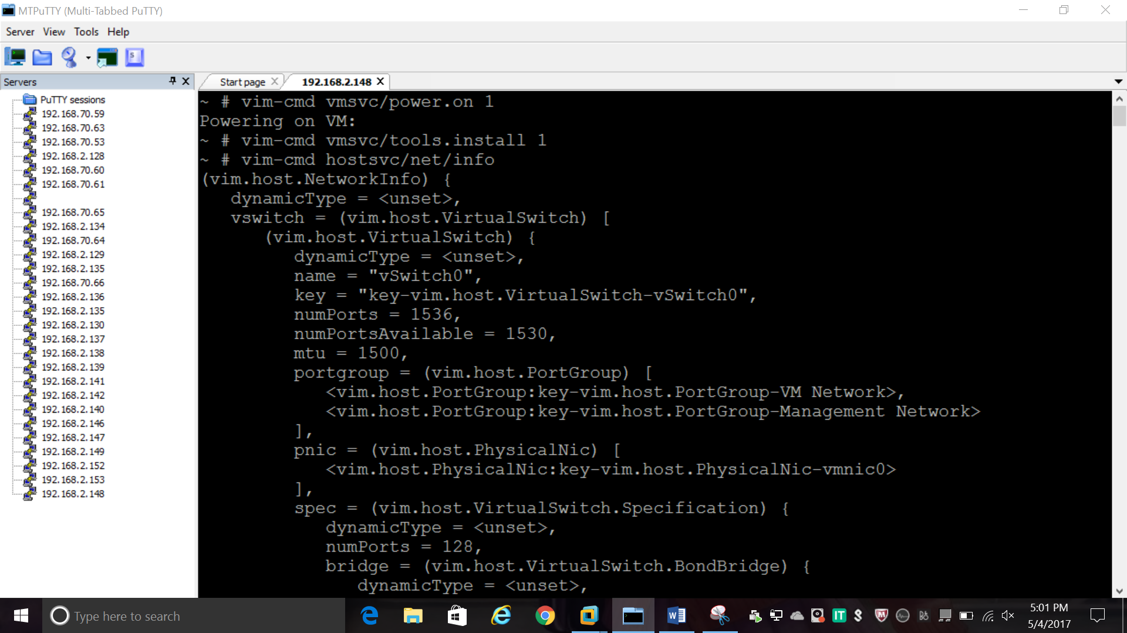

1. Shows daemons running on hypervisor. can also be used for configuration.

***chkconfig -l***

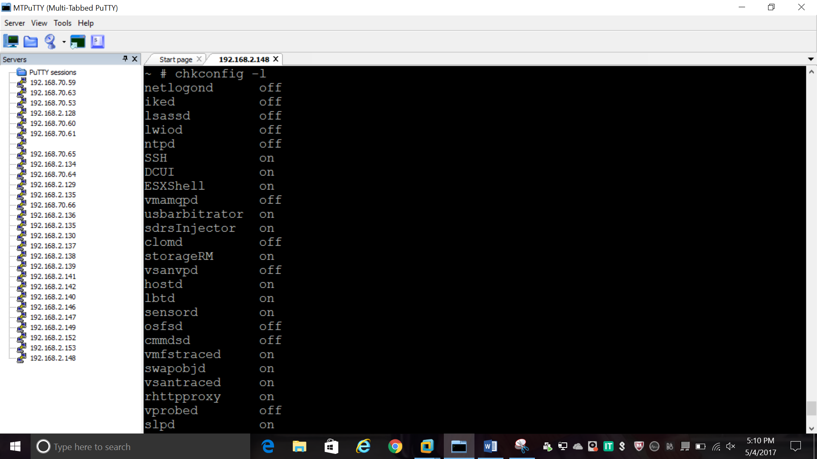

1. Similar to top command in Linux

**esxtop**

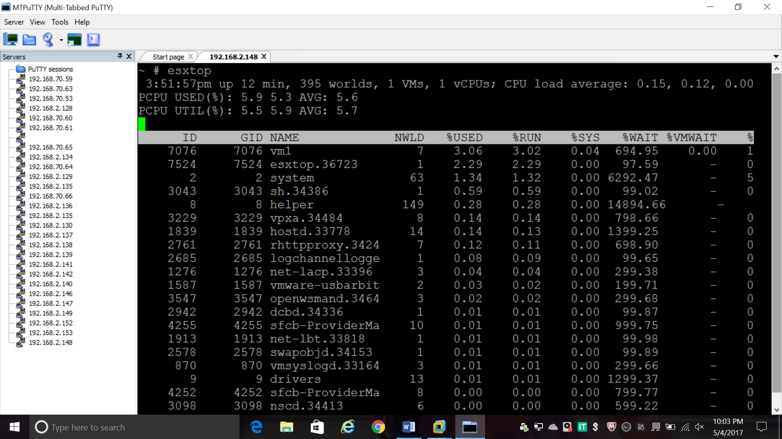

1. List of VMkernel error

***vmkerrcode –l***

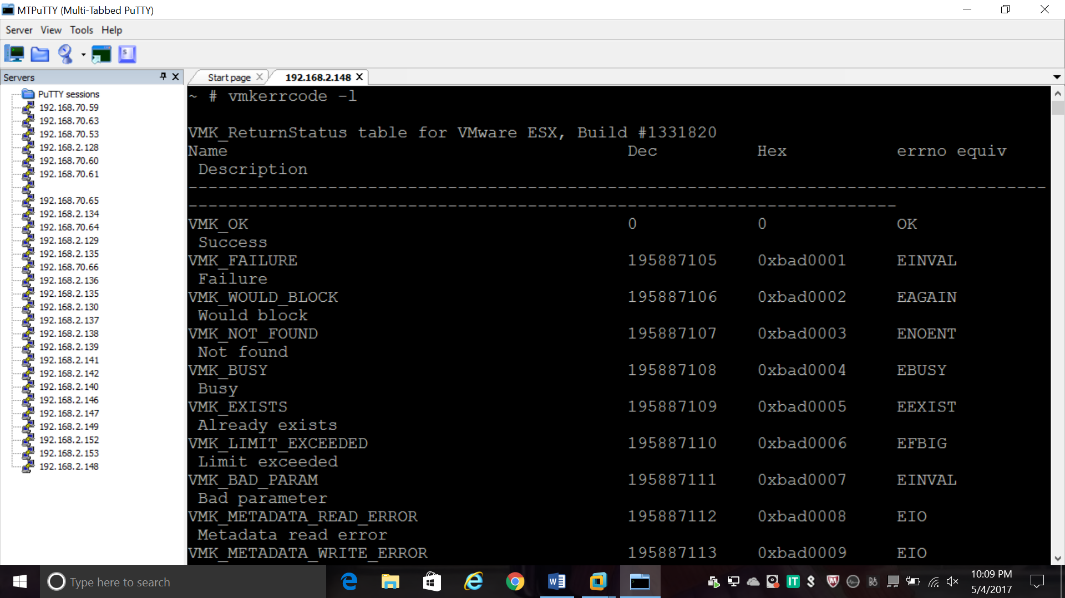

1. *List LOT of information about esx host*

***esxcfg-info***

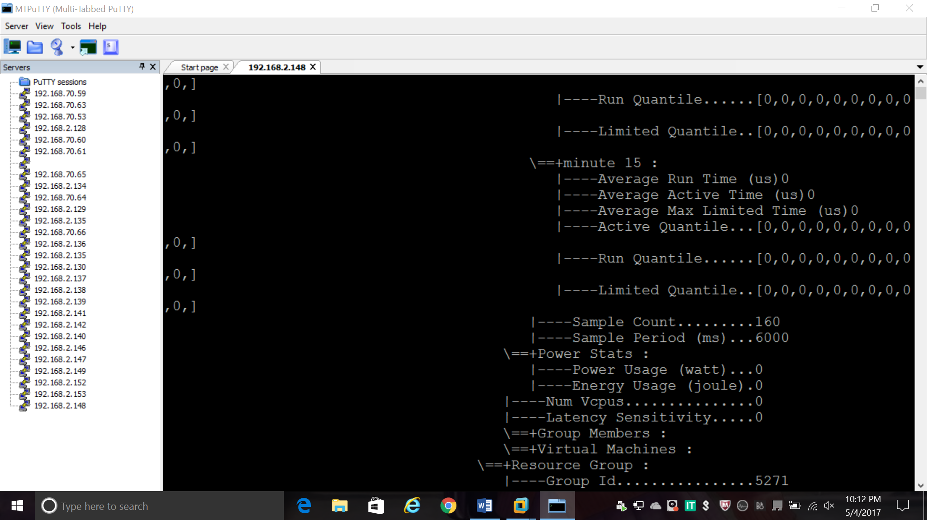

1. *Provides console screen to ssh session*

***dcui***

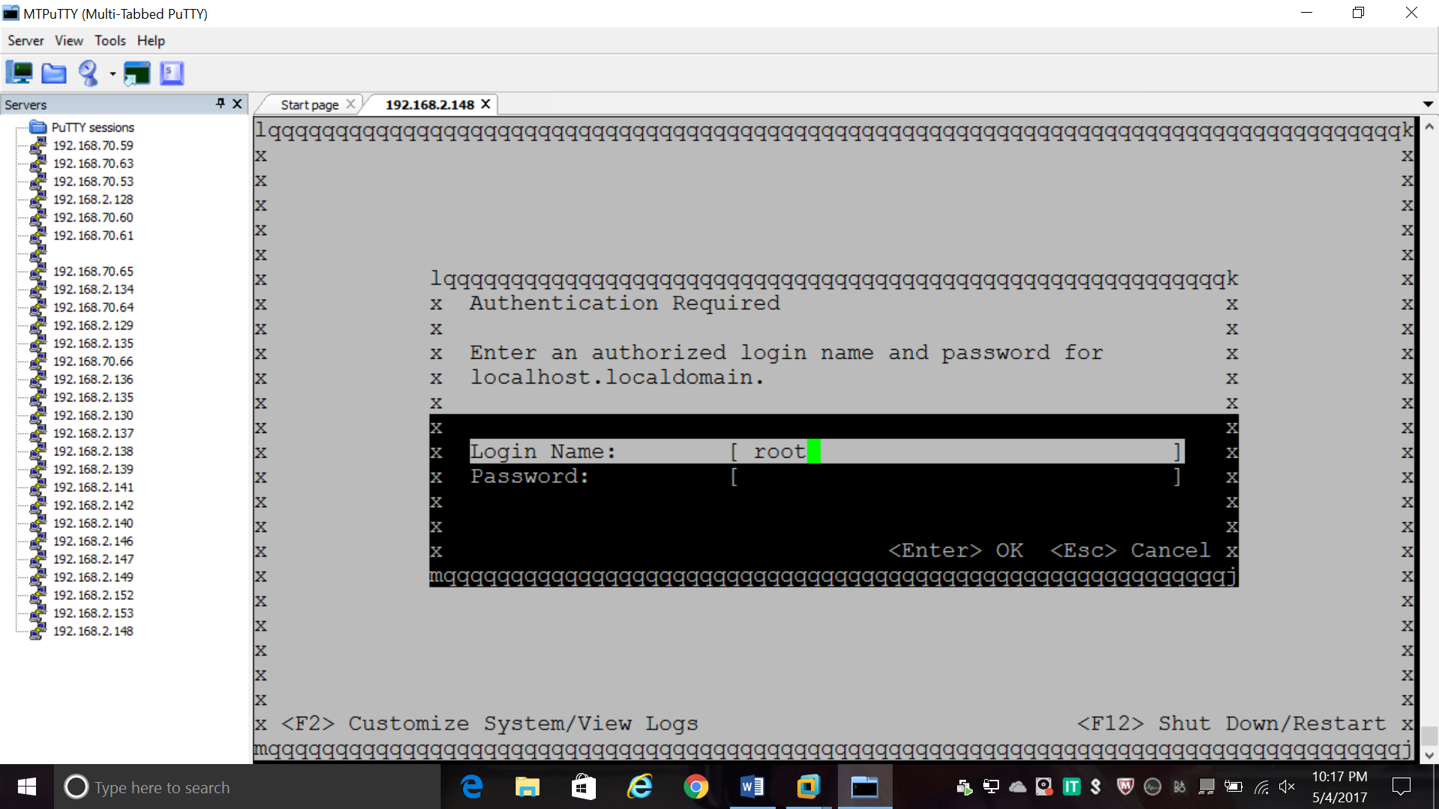

1. *Vmware interactive shell*

***vsish***

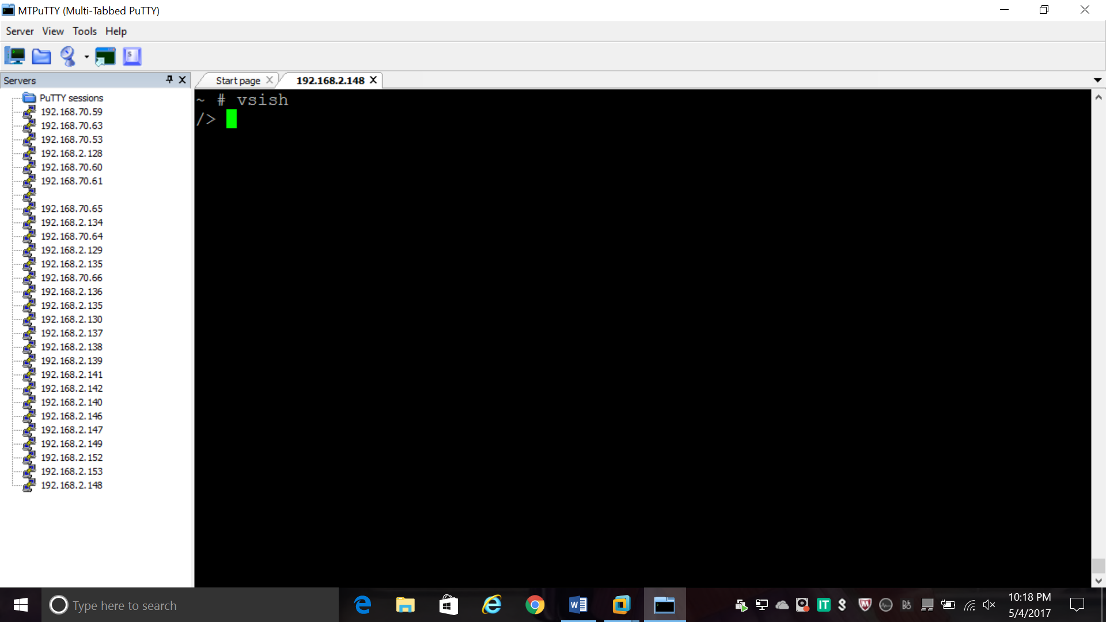

1. **Virtual Machine Storage Location:**

**cd /vmfs/volumes/datastore1**

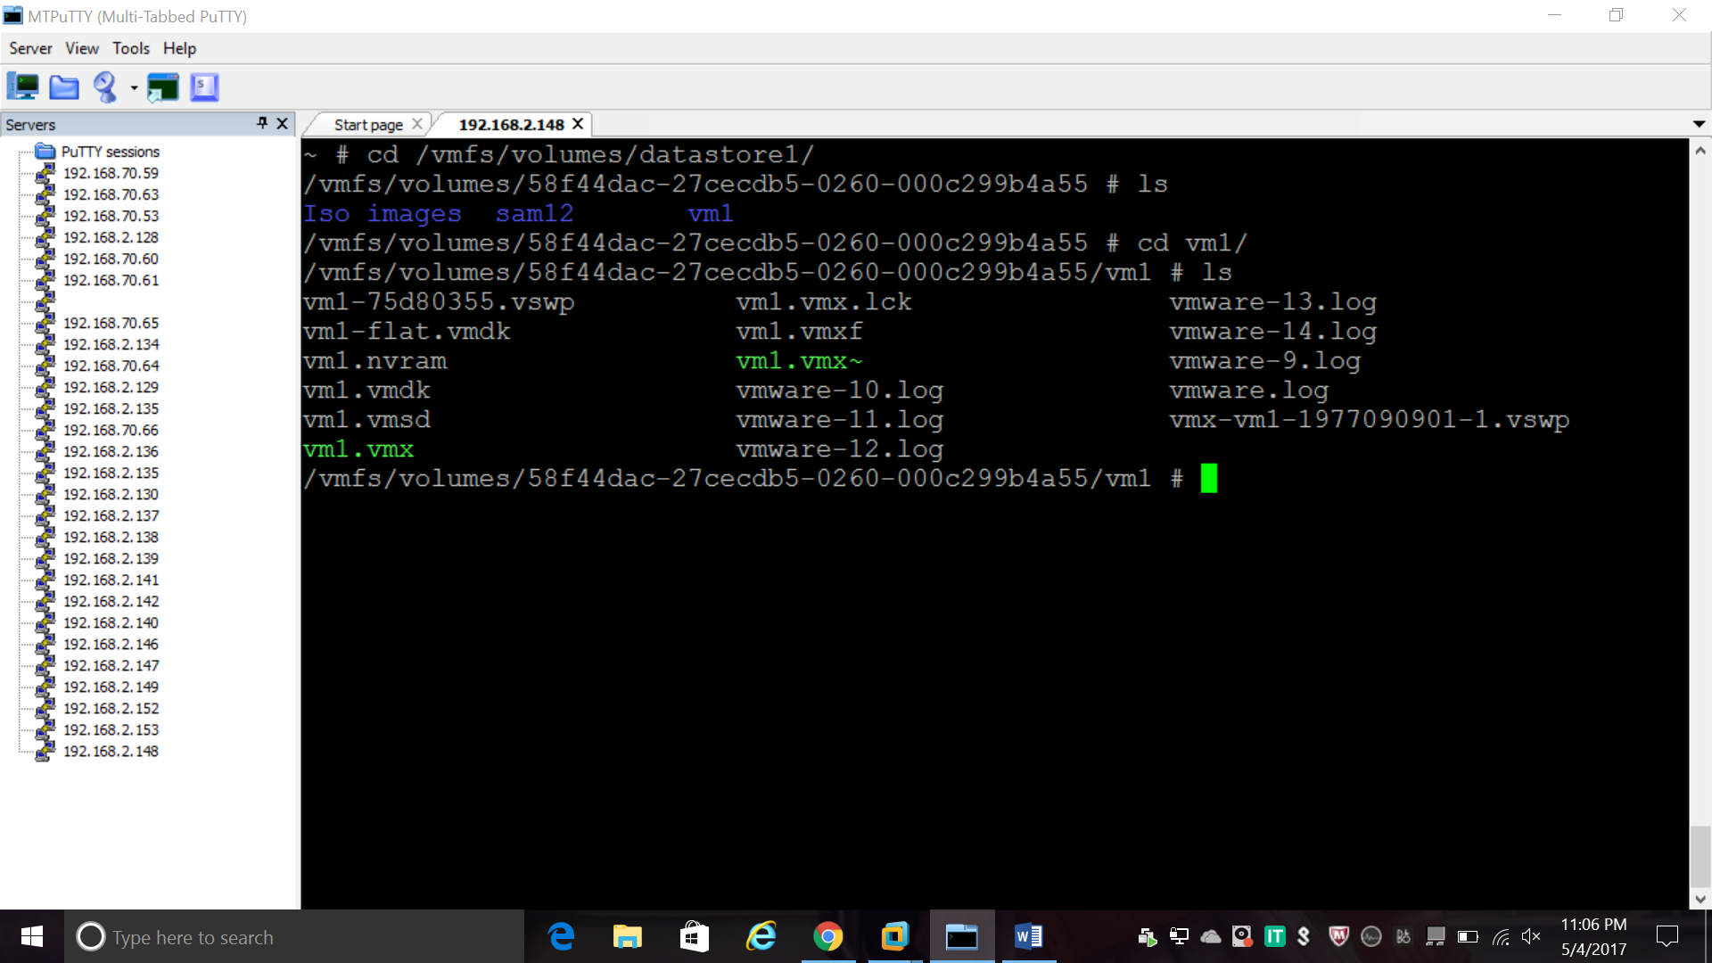

1. How Many Process Running on your esxi

***esxcli system process stats running get***

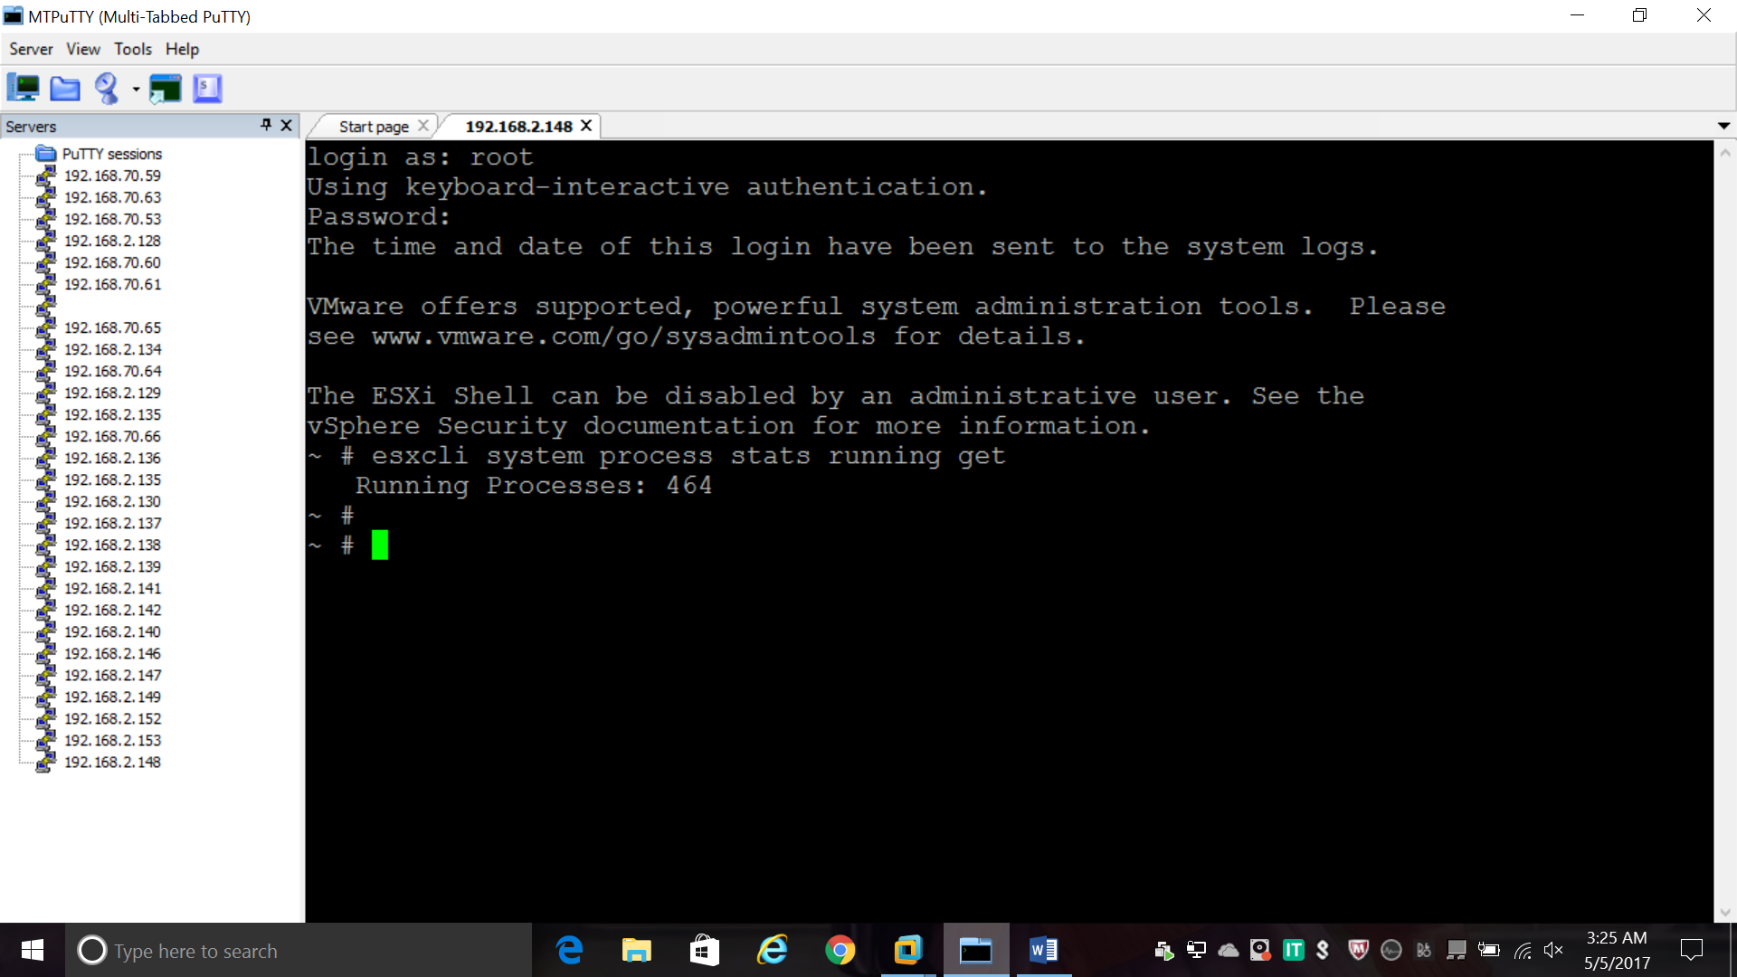

1. Cpu Information Related to esxi

***esxcli hardware cpu global get***

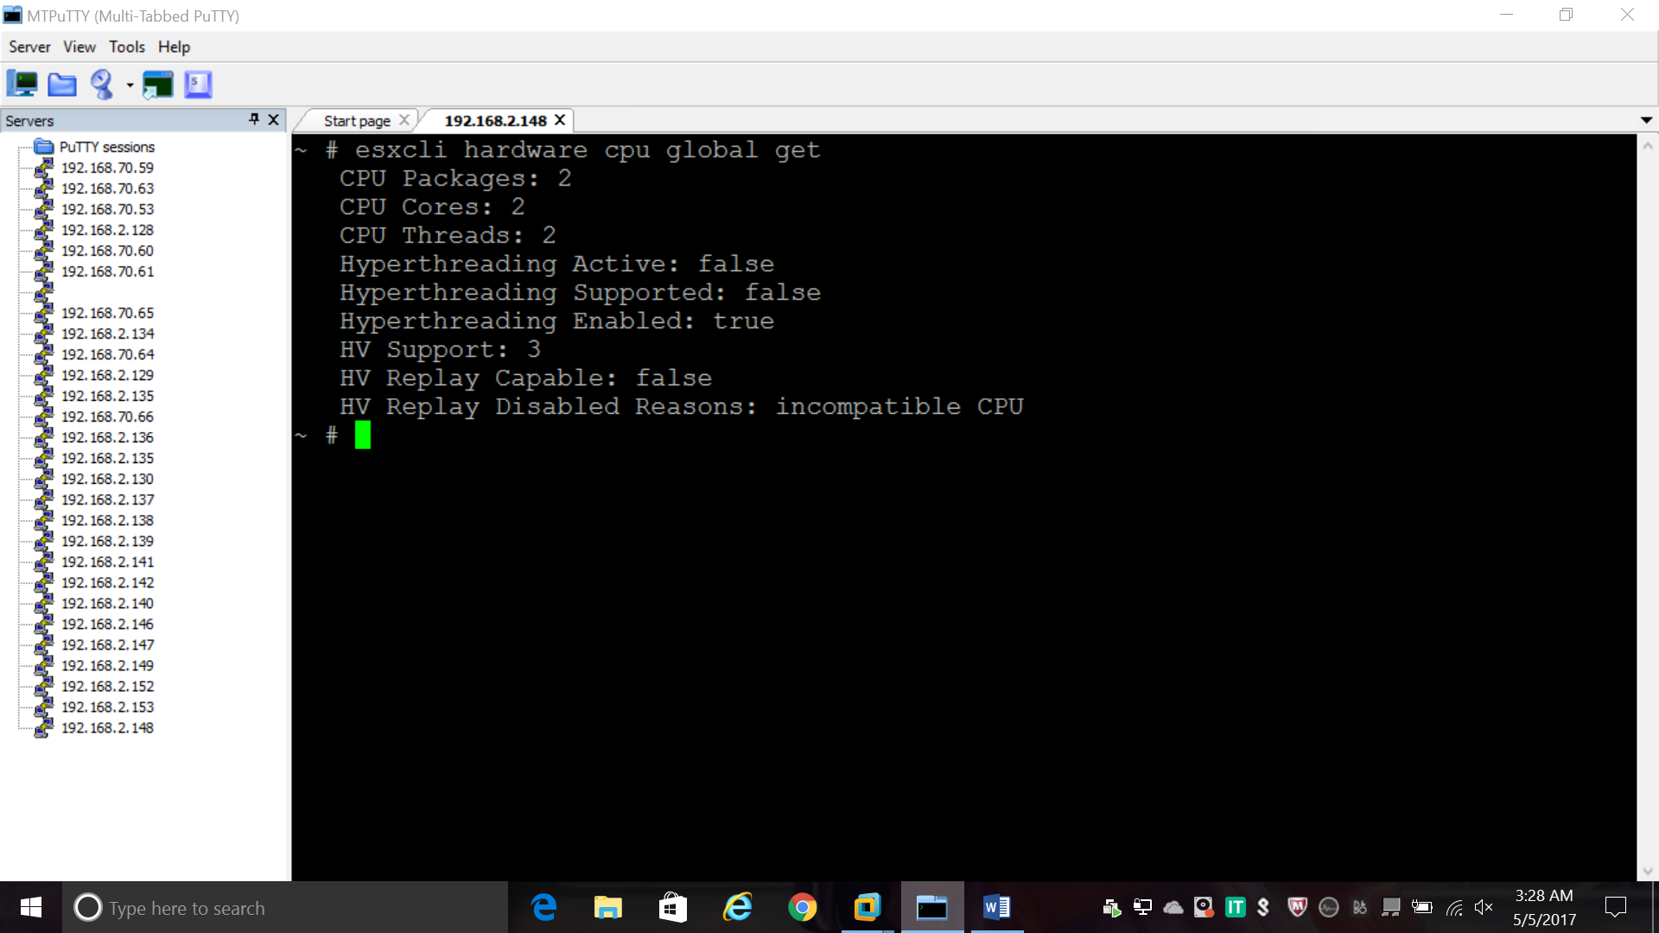

1. Physical Memory

***esxcli hardware memory get***

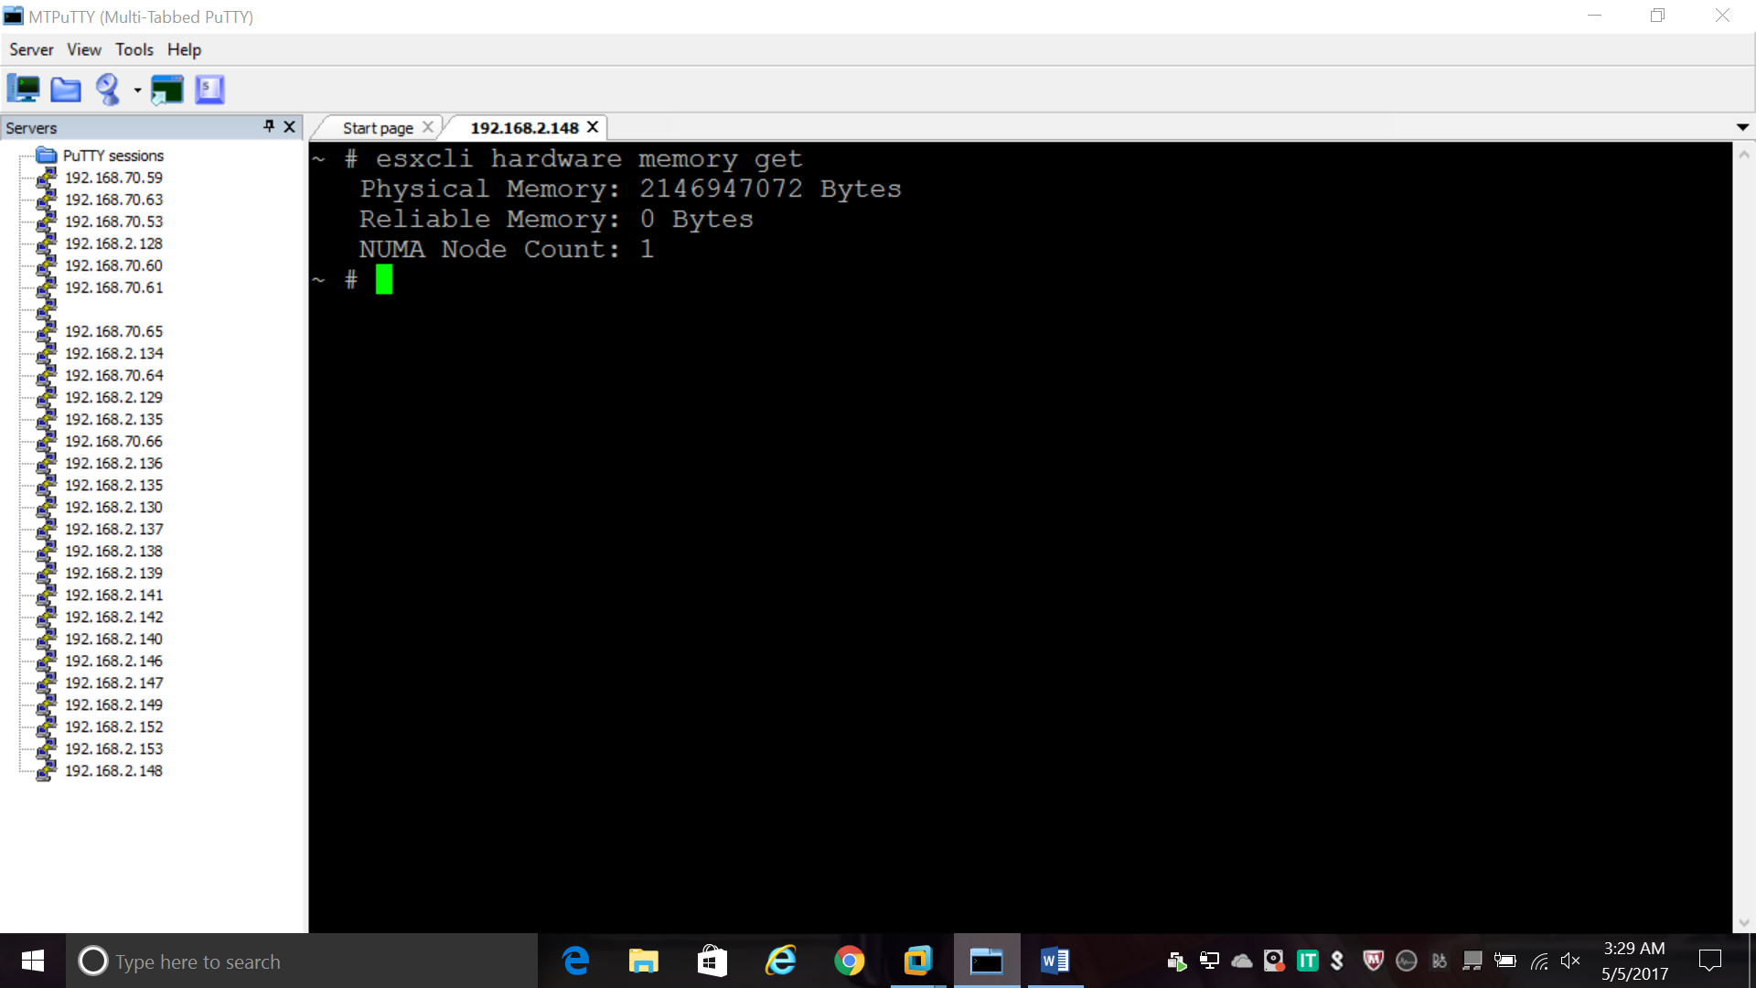

21 . List the details of Running VM

***esxcli vm process list***

